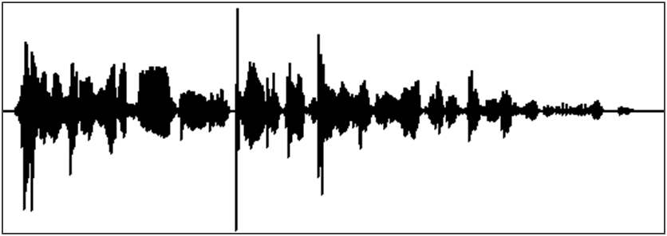

Windowing



**Fast Fourier Transform**

Analysis Stage

**SIGNAL PROCESSING**

PROCESSING



**Inverse Fast Fourier Transform**

Synthesis



**Overlap And Add**

*y(t)*

**Effect Processing**

*x(t)*

**Synthesis**

**Overlap and Add**

**Inverse FFT**

**Analysis**

**Windowing**

**FFT**

Frequency Domain